ASSIGNMENT-12.4
Course: AI Assisted Coding
Name: Ch.Shreevidya
HT NO: 2403A51419
Batch- 16
Screenshots:
Task 1:
Prompt:
write a python program bubble sort using doc strings and inline comments.please consider one example.
Code & Output:
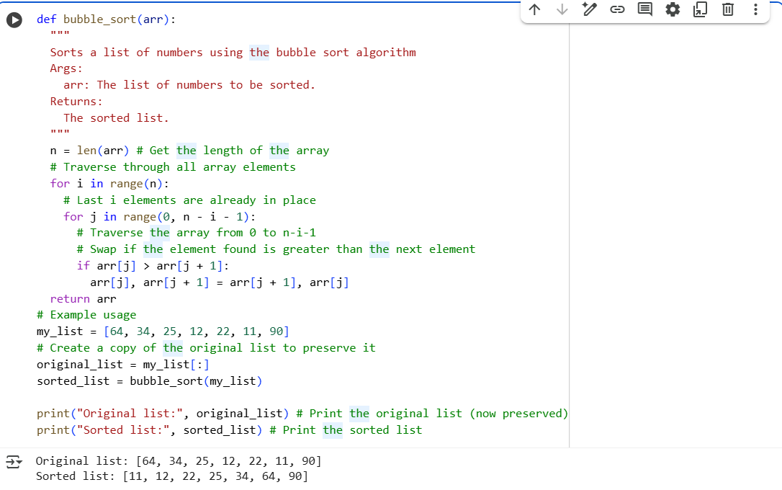

Task 2:
Bubble sort Code:


Insertion sort code:
Prompt:
Write the alternative(insertion sort) for the previous program .
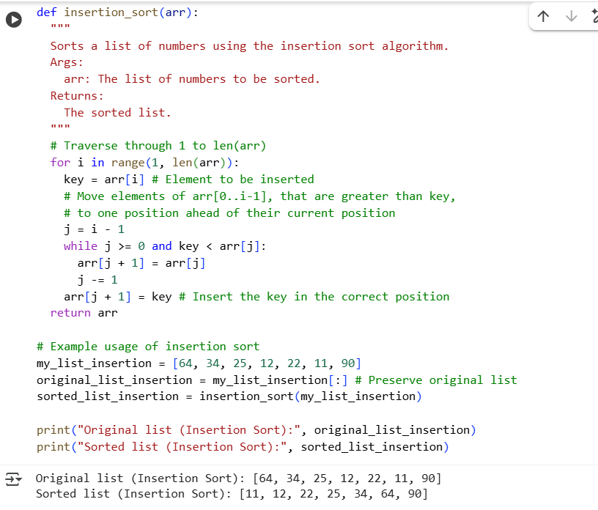
Comparision:
- How they move numbers: Bubble sort "bubbles" the largest unsorted number to its correct place in each pass by swapping adjacent items. Insertion sort takes one unsorted number and "inserts" it into its correct place within the already sorted part of the list.
- Efficiency for mostly sorted lists: Insertion sort is generally faster than bubble sort if the list is already almost sorted. Bubble sort will still do many comparisons even if the list is nearly sorted.
- How they stop: The basic bubble sort always goes through all the passes. The optimized bubble sort and insertion sort can potentially finish earlier if the list becomes sorted before the maximum number of passes.

Task 3:
Prompt:
Write a program that implements linear search.
Code & output:
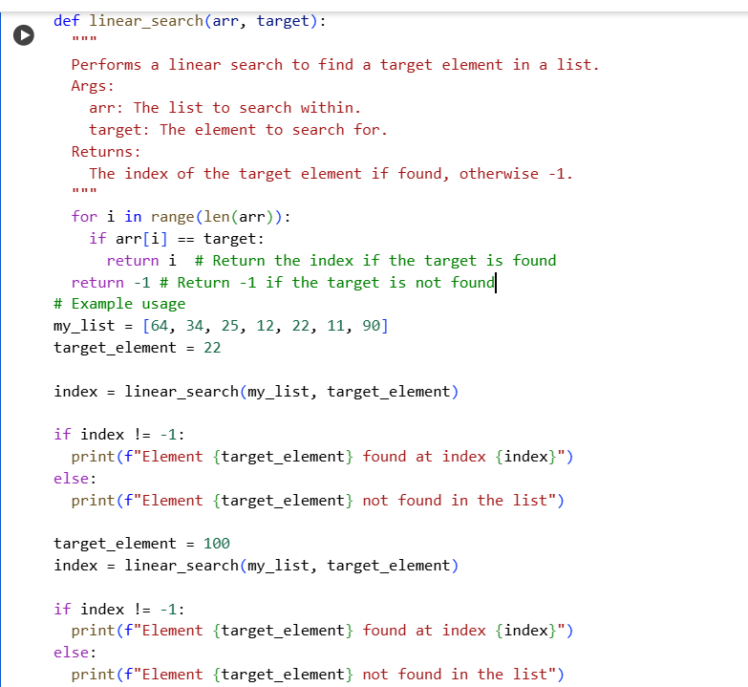
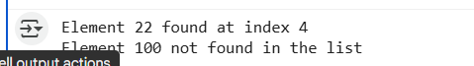
Prompt:
Write a program that implements binary search.
Code& Output:
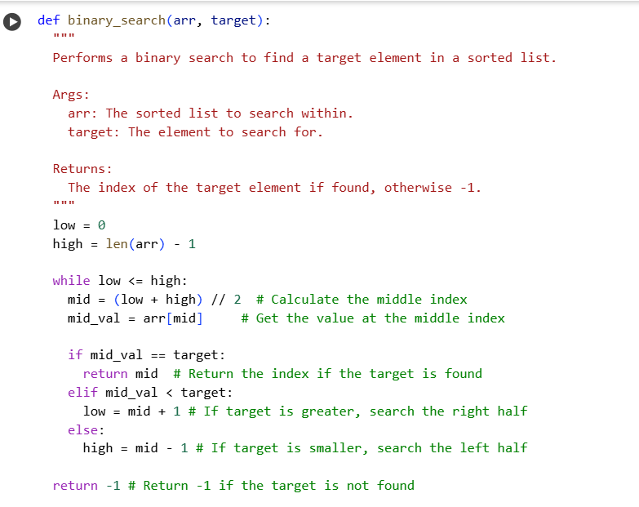
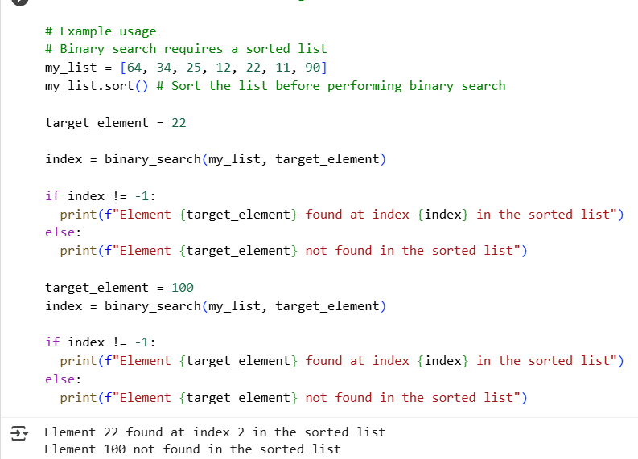
Comparision of linear search and binary search:
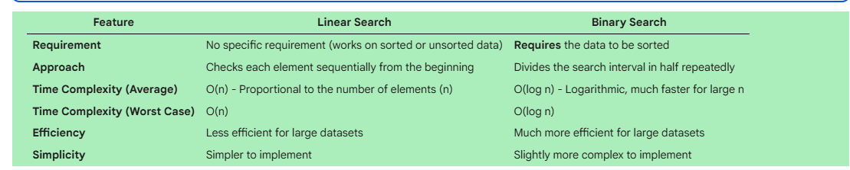
Task 4:
Prompt:
Write a python program that implements quick sort .consider one example.
Code& Output:
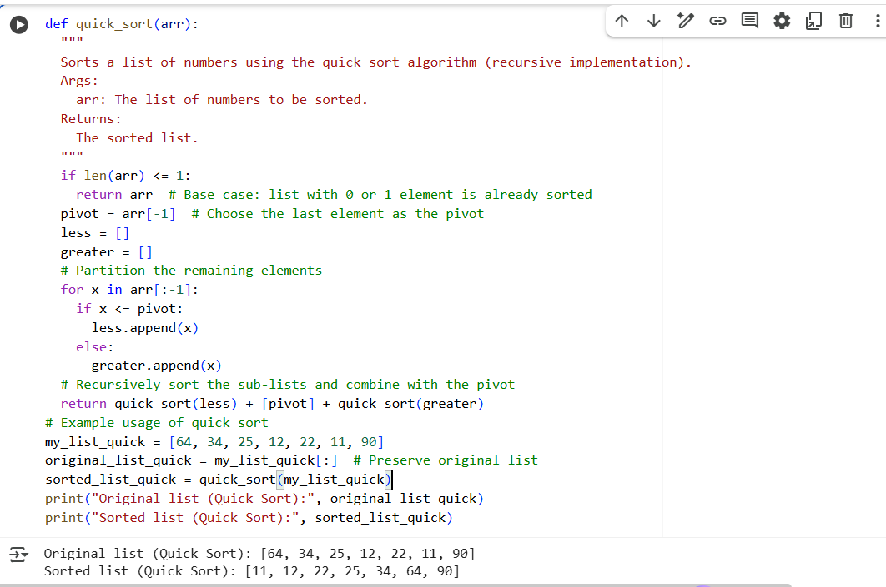
Prompt:
Write a program in python that implements merge sort.consider one example.
Code & Output:
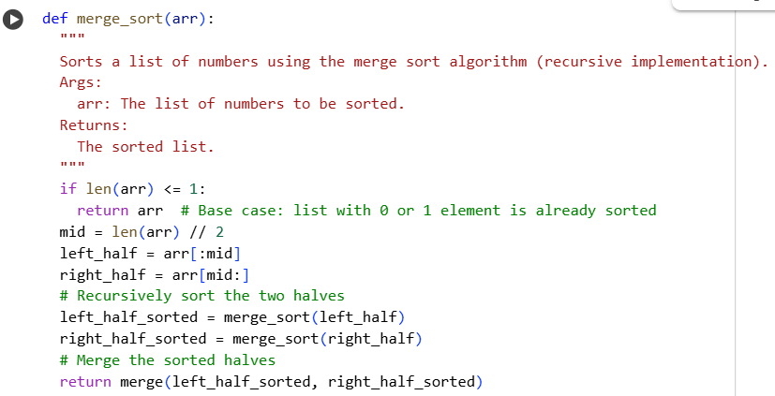
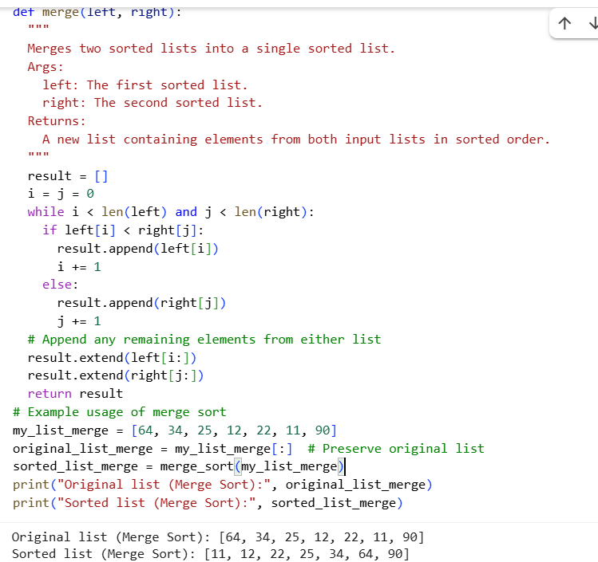
Comparision:
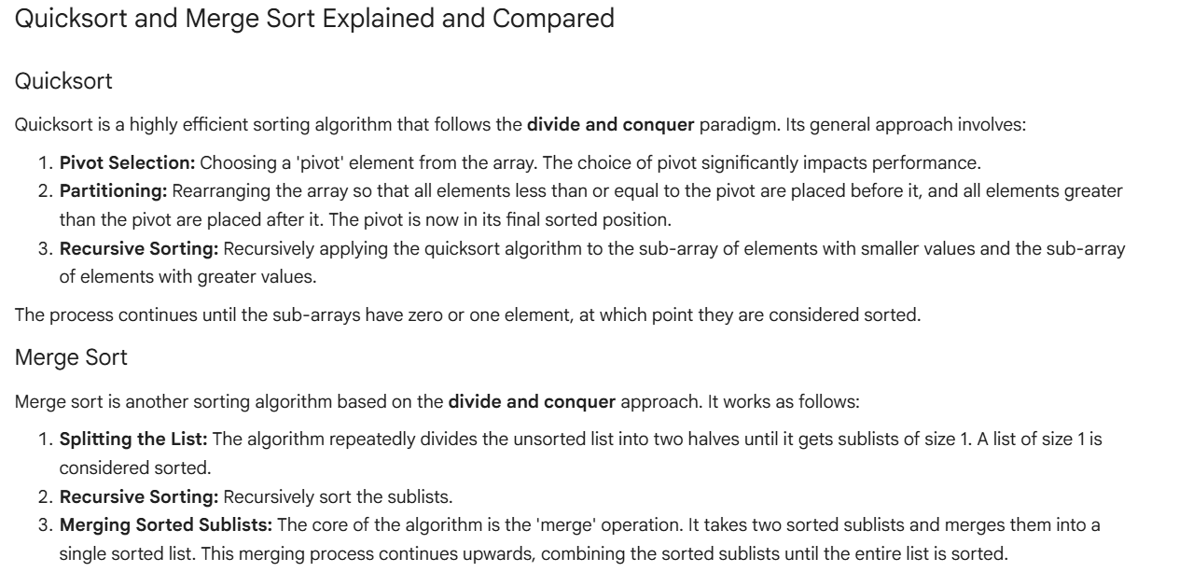
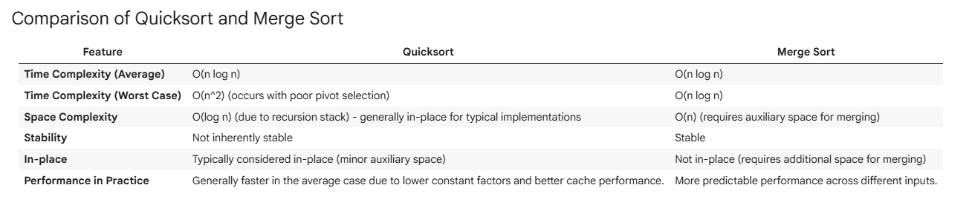
Task 5:

